

**PES UNIVERSITY**

**(Established under Karnataka Act No. 16 of 2013)**

**100-ft Ring Road, Bengaluru – 560 085, Karnataka, India**

***Report on***

**‘ROBOTIC ARM BCI’**

***Submitted by***

**HARSHITA R VASTRAD (PES1201701717)**

**V SAISRI (PES1201701763)**

**SHREYA V DEEXIT (PES1201701648)**

**Aug 2020 – May 2021**

**under the guidance of**

***Internal Guide***

**Dr. Niranjana Krupa**

**Professor**

**And**

**Prof. Shweta G**

**Assistant Professor**

**Department of ECE**

**PES University**

**Bengaluru -560085**

**FACULTY OF ENGINEERING**

**DEPARTMENT OF ELECTRONICS AND COMMUNICATION ENGG**

**PROGRAM B.TECH**



**CERTIFICATE**

*This is to certify that the Report entitled*

**‘Robotic Arm BCI’**

*is a bonafide work carried out by*

**HARSHITA R VASTRAD (PES1201701717)**

**V SAISRI (PES1201701763)**

**SHREYA V DEEXIT (PES1201701648)**

In partial fulfillment for the completion of 7th semester course work in the Program of Study B.Tech in Electronics and Communication Engineering, under rules and regulations of PES University, Bengaluru during the period Aug – Dec. 2020. It is certified that all corrections/suggestions indicated for internal assessment have been incorporated in the report. The report has been approved as it satisfies the 7th semester academic requirements in respect of Capstone project work.

*Signature with date & Seal Signature with date & Seal*

*(Dr/ Prof …..) Dr. Anuradha M*

*Internal Guide Chairperson*

*Signature with date & Seal*

*Dr. B. K. Keshavan*

*Dean - Faculty of Engg. &Technology*

Name and signature of the examiners:

1.

2.

**DECLARATION**

We, Shreya V Deexit, V Saisri, Harshita R Vastrad**,** hereby declare that the report entitled, ‘***Robotic Arm BCI’,*** is an original work done by us under the guidance of **Dr.Niranjana Krupa**, Professor, ECE department and **Prof.Shweta G**, Assistant Professor, ECE Department and is being submitted in partial fulfillment of the requirements for completion of 7th Semester course work in the Program of Study, B.Tech in Electronics and Communication Engineering.

**PLACE : BANGALORE**

**DATE : 08/01/2021**

**NAME AND SIGNATURE OF THE CANDIDATES**

1.**Harshita R Vastrad -**

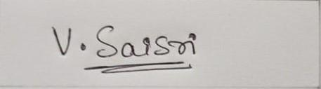

2.**V Saisri -**



3. **Shreya V Deexit -**

**ABSTRACT**

Latest brain computer interface (BCI) technology that can interpret brain EEG signals has

helped in successful robot regulation, resulting in the rise of Brain Robot Interface (BRI)

(BRI). This project focuses on accurately classifying the user's Action/Cognitive thoughts,

where successful EEG signal decoding can provide a higher degree of freedom regulation in

BRI applications. The user's scalp EEG signals are captured using a non-invasive electrode

and then prepossessed to generate noise-free EEG signals. Techniques such as

Time-Frequency Analysis is used to derive features from the EEG signal. To learn the EEG

signal features for successful output classification, an Artificial Neural Network(ANN)

machine learning algorithm is used in this work as a classifier. This paper examines the

system's accuracy using a proposed combination of Time-Frequency analysis and the ANN

algorithm for EEG feature extraction and classifier, respectively.

**Keywords:** electroencephalography (EEG); brain-computer interface (BCI); brain-robot interface (BRI); motor-imagery (MI)

**Acknowledgement**

**With immense pleasure, presenting our project ‘BCI Robotic Arm’ report as a part of our curriculum in ‘B.Tech in Electronics and Communication Engineering’. We wish to all people who gave us endless support throughout.**

**We express our profound gratitude to our guide Dr. Niranjana Krupa and Prof.Shweta G for giving us guidance and encouragement throughout the course of our project.**

**Shreya V Deexit**

**V Saisri**

**Harshita R Vastrad**

**TABLE OF CONTENTS**

**1. Introduction**  10

1.1. Problem Statement………………………………………………..11

1.2. Objective………………………………………………………….11

**2. Literature review**  12

2.1. Brain Controlled Interface…………………………………….......13

2.2. Electroencephalogram (EEG)…………………………………..........13

2.3. Motor Imagery……………………………………………………14

2.4. Wavelet Packet Decomposition…………………………...............14

2.5. Related Work..…………………………………………………….15

**3. Methodology**  16

3.1. Extracting the data………………………………………...............16

3.2. Pre-processing…………………………………………………….20

3.3. Wavelet packet decomposition…………………………………....21

3.4. Building the model……………………………………………….24

3.5.10-fold cross-validation…………………………………………...27

**4. Block Diagram**……………………………………………………………28

**5.Design of Robotic Arm**……………………………………………………29

**6. Result**……………………………………………………………………...31

**7. Analysis of result**…………………………………………………………32

**8. Conclusion**………………………………………………………………..33

**9. Future scope**………………………………………………………………33

**10. References**……………………………………………………………….34

**List of tables**

Figure 1: Brain Robot Interface Schematic…………………………………………………..12

Figure 2: Timing scheme of each trial paradigm…………………………………………….19

Figure 3: Frequency spectrum after bandpass filtering………………………………………21

Figure 4. DWT signal decomposition………………………………………………………..23

Figure 5. EEG Signal DWT decomposition………………………………………………….23

Figure 6: Summary of the model……………………………………………………………..25

Figure 7: Illustration of early stopping……………………………………………………....26

Figure 8: Train test split……………………………………………………………………...27

Figure 9: Process step flow diagram…………………………………………………………28

**List of figures**

Table 1:List of event types…………………………………………………………………...18

Table 2: Decomposition level for frequency bands…………………………………………..22

Table 3: Accuracy of Classification………………………………………………………….31

**1. INTRODUCTION**

Neural engineering has contributed to an area in neurotechnology called the Brain Computer Interface that explicitly connects computer systems and brain functions from a human being over the last few decades . A BCI system reads the user's purpose by converting electrophysiological signals acquired over the scalp [electroencephalography (EEG)], over the cortical surface [electrocorticography (ECoG)], and within the brain [single-neuron action potentials (single units) and local field potentials (LFPs)] into a code.BCI technology has the potential to help seriously disabled people with daily activities and human-machine interface applications. The number of independent degree of freedom (DOF) obtained from a user's brain signals is the main attribute in a BCI system that defines how well a BCI system can perform or how well a user can control a system.Robots are increasingly being used in human-machine interface systems to enhance quality of life, in addition to robotics and industrial applications. Assistive robots can help disabled people perform everyday tasks in both their personal and professional lives, resulting in increased demand for them. A safe consumer can monitor the robots with a variety of traditional input control devices such as a keyboard, a mouse, a motion sensor, or a teach pendent in general Human Machine Interface. These machines, on the other hand, are very difficult for elderly or disabled people with multiple sclerosis or amyotrophic lateral sclerosis to use.

One of the most common neurological disorders is paralysis, which results in the loss of motion in one or more muscles of the body. Robots will help injured people who have suffered from neuromuscular injuries. Researchers designed the voice-controlled robots to assist the disabled. There are also a variety of ways to use robots that concentrate on the contact between the person and the robot without the use of a human's hand. By having the requisite facilities and preparation, certain patients' Brain Signals may be used to assist them in communicating with others as well as performing different tasks. The BCI device interprets the brain's electrical activity and produces instructions. As a result, these commands can be used to monitor external machines.

**1.1. Problem Statement**

* To use a brain-computer interface (BCI) to communicate between a robot and a person without the use of a human hand, and to assist patients with neurological disorders.
* The robotic arm will be able to pick up lightweight objects such as medications, water bottles, and other items from one position and drop them to a predetermined location based on the user's brain waves.

**1.2. Objective**

* **To use brain waves to control robotic arm movement:**
  + Pre-processing the dataset,
  + classifying and sending the classified signal output to robot for arm movement.
* **Image processing for recognition of objects to pick and drop:**
  + This process involves object detection.
  + The robot will be able to
    - detect objects,
    - Avoid obstacles,
    - pick and drop the detected object.
* The outcome of this process is movement of the robotic arm without any motion or gesture in the patients.

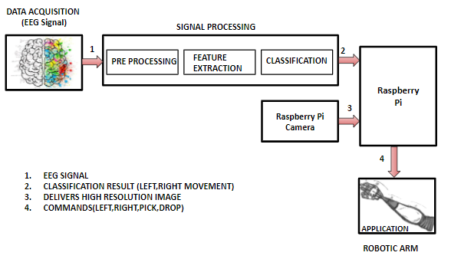**Figure 1: Brain Robot Interface Schematic**

**2. LITERATURE REVIEW**

2.1. Brain Controlled Interface

Brain Computer Interfaces (BCIs) track brain activity by using electrodes to sense electric signals in the brain that are then transmitted to a computer. After that, the computer extracts features from the task and converts them into outputs that substitute, restore, enhance, complement, or boost human functions.

2.2. Electroencephalogram (EEG)

The electroencephalogram (EEG) is a scalp recording of the brain's electrical activity. The cortical electrical activity is reflected in the reported waveforms.

EEG signal amplitude is usually measured in microvolts (mV).

The following are the primary frequencies of human EEG waves:

1.Delta waves are the slowest. It is common as the dominant rhythm in infants up to one year old, as well as in sleep stages 3 and 4.

2.Theta- action is graded as "slow." It is common in children under the age of 13 and when they are sleeping, but it is rare in awake adults.

3.Alpha- is commonly seen in the posterior sections of the head on both sides, with the dominant side having a higher amplitude. It occurs when you close your eyes and relax, and it vanishes when you open your eyes or are alerted by some process such as thought or measuring.

4.Beta- is a form of "fast" operation. It has a symmetrical distribution on both sides and is visible from the front. It is generally thought to be a natural rhythm.When people have their eyes open, are alert, or are nervous, this is the dominant rhythm.

2.3. Motor Imagery

One of the standard concepts of BCI is motor imagery based brain-computer interface (MI). In MI, the user can produce induced activity from the motor cortex of the brain by imagining motor movements without any hand movement or external stimulus.

The most convenient basis for designing brain-computer interfaces is motor imagery signals recorded through electroencephalography. Since MI-based BCI allows for a high degree of independence, it enables motor-disabled people to communicate with the system by performing MI tasks in sequence.

2.4. Wavelet Packet Decomposition

The Discrete Wavelet Transform (DWT) is a multi-resolution time-frequency study of signals. The main advantage of the DWT over the Fourier Transform is that it has temporal resolution as well as frequency resolution information, which is why it is called a time-frequency analysis.

Wavelet packet analysis methods are commonly used to pre-process data, resulting in a reasonably satisfactory ANN modelling performance. Typically, the decomposition level chosen is based on the length of the sequence. The maximum decomposition level (M) can theoretically be determined as M = log2 (N), where N is the length of the sequence.

The wavelet becomes smoother as the number of vanishing moments increases (longer the wavelet filter). The wavelet filter has a length of two times that amount. The meaning of this is that if the signal behaves in an interval that is compatible with a polynomial of degree at most N and the wavelet has N vanishing moments, the wavelet coefficients in that interval will be zero. Polynomials of degree at most N are orthogonal to a wavelet with N vanishing moments. If the signal is a polynomial of degree at most 1 in the interval, a "db1" will return wavelet coefficients of zero in the interval.

2.5. Related Work

Reference paper[2] was the main reference paper used to introduce ‘Robotic Arm BCI.' We learned how to build a hybrid deep learning model using the CNN and the BiLSTM by using a bandpass filter with Hamming-windowed zero step finite impulse response (FIR). Twenty EEG channels near the primary/supplementary motor cortices were chosen after spatial filtering. The MDCBN-based multidirectional CNN-BiLSTM network (MDCBN) deep learning system was used to consider 3D multi-direction.

Using the reference paper[1], the ICA (Independent component analysis) algorithm was used to eliminate the polluted channels. The zero-phase second-order Butterworth bandpass filter with a cutoff frequency of 4 to 40 Hz, as well as the HF-CNN model of classification, were all learned from this paper. Because of the EEG uncertainty characteristics, they trained the HF-CNN according to each subject.

Reference [5] was used to investigate various classification techniques. They used three separate classification algorithms in this paper: SVM, KNN, and LDA. When all classifiers were compared, LDA had a higher accuracy of about 87.5 percent. Matlab and an Arduino board were used to interface with the robotic arm. The robotic arm is controlled wirelessly by the Bluetooth module.

The paper[3] introduced the idea of spatial filtering using typical spatial patterns. This paper also provided a brief overview of the Mutual knowledge (MI) algorithm for feature selection and the naive bayesian classifier for classification.

A comparison of different BCI classifiers was presented in a reference paper[4].

It provided an overview of the various classification strategies currently in use in the field of BCI. Linear Discriminant Analysis (LDA), Support Vector Machine (SVM), k-Nearest Neighbor (kNN), LSTM, Bi-LSTM, CNN-LSTM, and Bi-LSTM CNN are some of the techniques used. This aided us in comprehending the variety of applications and the various models.

**3. METHODOLOGY**

3.1. Extracting the data

3.1.1. The Dataset

Graz University provided Dataset BCI Competition IV 2a, which we used. This dataset contains EEG data from nine healthy subjects who performed four types of motor imagery: right hand, left hand, feet, and tongue movement. For each subject, the dataset is recorded in two sessions on separate days. One of the sessions was used for instruction, while the other was used for assessment. Each training and assessment session consists of six runs separated by short breaks, with 48 trials in each run (12 trials for each class). There were 288 trials in each session (72 trials per class). Each trial consisted of instructing the participant to visualise one of four motor imagery tasks (Left hand, Right hand, Both Feet, and Tongue) in response to a cue shown on a monitor, as shown in figure 2's trial paradigm timing scheme.

The signals were captured from 22 EEG channels and three monopolar EOG channels in accordance with the international 10-20 framework. They were sampled at a rate of 250 Hz and band-pass filtered in the 0.5-100 Hz frequency range. To reduce power line noise, an additional 50 Hz notch filter was used. The EOG channels should not be used for classification and should instead be used to apply artefact removal methods afterward. The files are saved in.gdf format.

The workspace would then have two variables: signals s and a header structure h. There are 25 channels in the signal variable (the first 22 are EEG signals and the last three are EOG signals). The header structure stores event data that defines the data's structure over time. The fields below provide critical details for evaluating this data set:

h.EVENT.TYP

h.EVENT.POS

h.EVENT.DUR

h.EVENT.POS contains the location of an event in samples. The class for that event can be found in h.EVENT.TYP, and the period of that event can be found in h.EVENT.DUR.The types used in this data set are described in Table 1

|  |  |
| --- | --- |
| Event type | Description |
| 276 | Idling EEG (eyes open) |
| 277 | Idling EEG (eyes closed) |
| 768 | Start of a trial |
| 769 | Cue onset left (class 1) |
| 770 | Cue onset right (class 2) |
| 771 | Cue onset foot (class 3) |
| 772 | Cue onset tongue (class 4) |
| 783 | Cue unknown |
| 1023 | Rejected trial |
| 1072 | Eye movements |
| 32766 | Start of a new run |

**Table 1: List of event types**

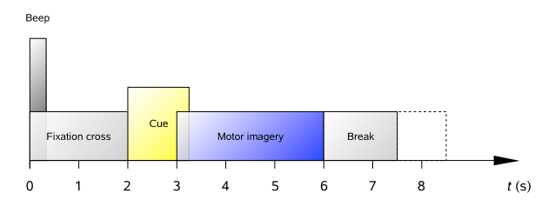

**Figure 2: Timing scheme of each trial paradigm**

**3.2. Pre-processing**

**3.2.1. Event Extraction**

On the basis of the events, voluntary and fictional movements were gathered, and these events were extracted and divided into 11 forms. Only four events out of eleven were needed, and they are as follows:

i)Cue onset left (class 1)

ii)Cue onset right (class 2)

iii)Cue onset foot (class 3)

iv) Cue onset tongue (class 4)

**3.2.2. Bandpass Filtering**

EEG signals are noisy, and non-stationary signals include objects such as eye blinks, eye movement, heart signals, and muscle movement that must be filtered out of the raw EEG signal in order to maximise the signal-to-noise ratio.

After extracting the necessary events, we pass frequencies in a frequency band via a one-pass, zero-phase, non-causal bandpass filter with a hamming window. The frequency range of 7Hz to 35Hz has been chosen. Figure 3 depicts the area that was used in the model.

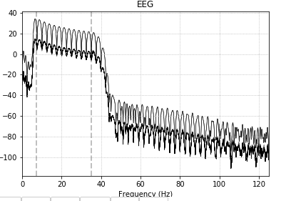

**Figure 3: Frequency spectrum after bandpass filtering**

**3.2.3. Channel Selection**

According to the literature review, the majority of EOG channel signals represent redundant information about brain function. The EEG signals are extracted using 25 electrodes, 22 of which are EEG channels and 3 of which are EOG channels. EOG channels are regarded as undesirable. The existence of EOG channels in the classification process will have an impact on the classification rate. As a result, these poor channels are omitted for improved accuracy, leaving 22 channels for classification.

**3.3. Wavelet packet decomposition**

We split the EEG signal into sub-bands such as Delta (0.5 to 4 Hz), Theta (4 to 8 Hz), Alpha (8 to 16 Hz), Beta (16 to 32 Hz), and Gamma ( >32 Hz) to analyse it.

On the filtered EEG signals, a two-level Discrete Wavelet Transform (DWT) with a mother wavelet of ‘db4' was applied, yielding three sets of comprehensive coefficients D3, D4, and D5 from the decomposed EEG signal.

|  |  |  |
| --- | --- | --- |
| Decomposition Level | Frequency Bandwidth(Hz) | Frequency Bands |
| D1 | 64-128 | Noise |
| D2 | 32-64 | Noise(Gamma) |
| D3 | 16-32 | Beta |
| D4 | 8-16 | Alpha |
| D5 | 4-8 | Theta |
| A5 | 0.5-4 | Delta |

**Table 2: Decomposition level for frequency bands**

A signal's single level DWT is determined by passing it through highpass and lowpass filters, which generate informative and approximated coefficients, respectively. Using Nyquist's law, half of the samples can be discarded by sub-sampling with 2. The estimated coefficients from each level are decomposed further for N multi-level DWT by repeatedly passing them through highpass and lowpass filters until the nth level informative and approximated coefficients are obtained, as shown in figure 4. The decomposed EEG signal in the frequency resolution can be seen in figure 5

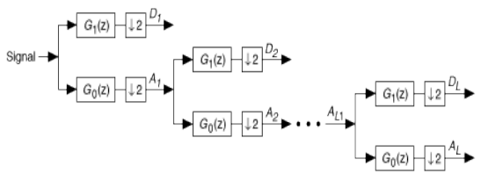

**Figure 4. DWT signal decomposition**

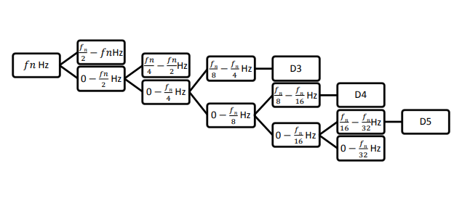**Figure 5. EEG signal DWT decomposition**

**3.4. Building the model**

Artificial neural networks architecture is used to classify the extracted features from the EEG signals into four groups. The model is made up of four layers. The neural network's performance matrix is 4x288, with four motor imagery tasks per 288 data samples. There are 124 neurons in the input layer. A 0.5 dropout is used. Relu is the activation feature used in this layer.

The model has two hidden layers, each with 124 neurons, a Relu activation feature, and a dropout of 0.5. The L2 regularisation method was used, and it worked well.

Since there are four groups to define, the output layer has four neurons.

Each class is represented by a neuron.

Softmax is the activation feature used in the output layer.

Since this is a multiclass problem, the optimizer chosen for this model is rmsprop, and the loss is categorical cross entropy.

The description of the model we used is shown in the diagram below.

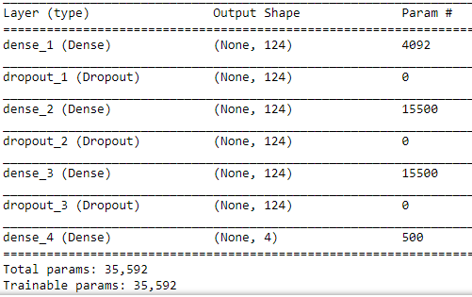

**Figure 6: Summary of the model**

*Early stopping*

The most common issue with neural network training is deciding how many training epochs to use. Overfitting the training dataset can result in a decrease in model accuracy, whereas selecting a small number of epochs can result in an underfit model. Early stopping is a technique that allows you to specify an arbitrary large number of training epochs and then stop training when the model's output on a hold out validation dataset stops improving.

The plot of training and validation failure against the number of epochs is shown in Figure 7.The training is stopped when the validity loss attempts to increase in relation to the training loss, as seen in the graph.

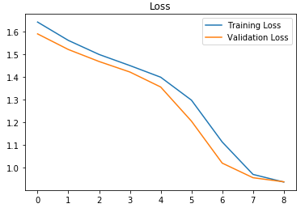

**Figure 7: Illustration of early stopping**

**3.5. 10-fold cross-validation**

The initial sample is randomly partitioned into 10 equal-sized subsamples in 10-fold cross-validation. A single subsample from the ten is held as validation data for testing the model, while the remaining nine are used as training data. The cross-validation process is then replicated ten times (the folds), with each of the ten subsamples serving as validation data exactly once.

The ten folds' results can then be summed to create a single estimate. This approach has the advantage of using all observations for both training and research, and each observation is only used for testing once.

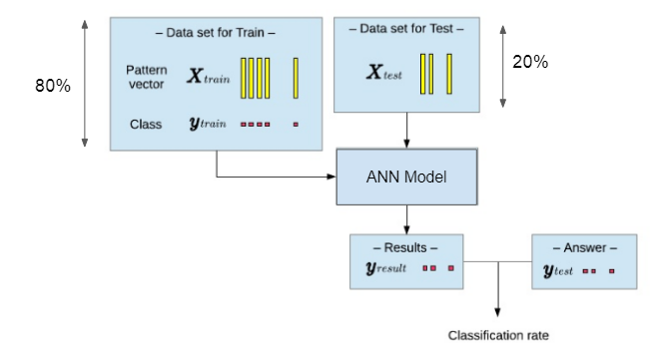

**Figure 8: Train test split**

**4. BLOCK DIAGRAM**

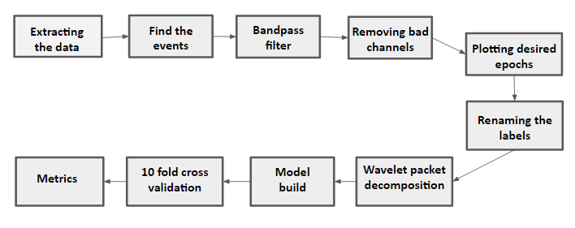

**Figure 9: Process step flow diagram**

**5. Design of the Robotic ARM**

**5.1. Factors to Take into Account**

The following considerations were considered when selecting the material for the robotic arm frame and its shape:

1.The price

2.The robot's weight

3.The ease with which the pieces can be manufactured

4.Assembly is easy.

5.Parts' sturdiness and longevity

The following are the basic specifications for effective power transmission by the robotic arm:

1.Size is small.

2.Low weight and inertia moment

3.Effective stiffness is high.

4.Transmission ratio that is accurate and consistent

5.Low energy losses and friction for improved control system responsiveness

6.Backlash will be eliminated.

Both of these considerations had a major impact on the robotic arm's design decisions.

### **5.2. Material Selection**

The stiffness-to-weight ratio of each connection is critical in manipulator design because inertial forces cause the largest deflections. As a result, a higher Modulus of Elasticity,E is highly desirable. Beryllium and ceramics have the best properties, but beryllium is expensive and ceramics are brittle. Aluminum (Al), Magnesium (Mg), and Titanium (Ti) are lightweight materials with similar stiffness-to-weight ratios to steel. They are used in applications where high strength and low weight are more critical than stiffness-to-weight ratios. However, these materials have a number of drawbacks, including ageing, creeping under continuous loads, and a high thermal expansion coefficient.

**6. RESULT**

The total accuracy of all four classes (class 1-left, class 2-right, class 3-down, and class 4-up) is obtained. The 10 Fold Cross Validation approach is used to measure the overall and average accuracy percentage of the neural network for the subjects across various statistical features. Table 3 shows the average classification accuracy, fold accuracy, kappa, precision, recall, and fold accuracy for different statistical features derived from 22 channels.

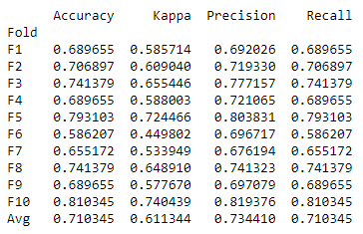

**Table 3: Accuracy of Classification**

**7. ANALYSIS OF RESULT**

Initially, only one hidden layer model was used. The average level of accuracy was 68 percent. We experimented with various parameters, such as the optimizer, the number of hidden layers, regularisation techniques, and the dropout value, in order to fine-tune the model. The best accuracy was achieved using a four-layer model with two hidden layers, a drop out of 0.5, rmsprop as the optimizer, and the L2 regularisation technique. We found that adding early stopping to our training process improved accuracy.

**8. CONCLUSION**

The arm of Brainiac is unique in that it can be seen in a variety of fields. First and foremost, it can be used for people with disabilities, as well as those who do not have a physical body. They can monitor their missing body part with the help of their brain . The benefit is that they can develop their mental and attention skills.

We developed our programme for robotic arm control in this paper.By changing model parameters such as the optimizer, dropout value, and number of layers, as well as adding early stopping to minimise overfitting and L2 regularisation. By comparing the accuracies of all the variants, we can conclude that the Adam optimizer, drop out of 0.5, 2 hidden Layers, early stopping, and L2 regularisation generated the best average accuracy of 71.03 percent.

**9. FUTURE SCOPE**

This demonstrates that there is still room for improvement in feature selection and network design, despite the fact that this study used a fixed architecture. It's important to think about how to choose the best bandwidth for the frequency spectrum of the EEG signal that needs to be filtered. Along with the optimization of feature selection and neural network design, the analysis can be carried out in an online training of the neural network and real-time control of the robot, allowing for several degrees of robot control to be experimented with and analysed.

**10. REFERENCES**

**[1]** JI-HOON JEONG1, BYEONG-HOO LEE1, DAE-HYEOK LEE1, YONG-DEOK YUN1, AND SEONG-WHAN LEE2,**”EEG Classification of Forearm Movement Imagery Using A Hierarchical Flow Convolutional Neural Network”**, (FELLOW, IEEE)

**[2]** Ji-Hoon Jeong , Kyung-Hwan Shim , Dong-Joo Kim , and Seong-Whan Lee, **“Brain-Controlled Robotic Arm System Based on Multi-Directional CNN-BiLSTM Network Using EEG Signals”**,[IEEE Transactions on Neural Systems and Rehabilitation Engineering](https://ieeexplore.ieee.org/xpl/RecentIssue.jsp?punumber=7333) (Volume: 28 , [Issue: 5](https://ieeexplore.ieee.org/xpl/tocresult.jsp?isnumber=9090036), May 2020 )

**[3]** [Maryam Mohammadi](https://ieeexplore.ieee.org/author/37086353197); [Mohammad Reza Mosavi](https://ieeexplore.ieee.org/author/37299368300)**,”Improving the efficiency of an EEG-based brain computer interface using Filter Bank Common Spatial Pattern”,**[2017 IEEE 4th International Conference on Knowledge-Based Engineering and Innovation (KBEI)](https://ieeexplore.ieee.org/xpl/conhome/8316804/proceeding)

**[4]** Aldwin Jomar F. Castro , Justine Nicole P. Cruzit **“Development of a Deep Learning-Based Brain-Computer Interface for Visual Imagery Recognition”,** [2020 16th IEEE International Colloquium on Signal Processing & Its Applications (CSPA)](https://ieeexplore.ieee.org/xpl/conhome/9052211/proceeding)

**[5]** C P Shantala,C R Rashmi,**“Mind controlled wireless robotic arm”**,2017 IEEE International Conference on Computational intelligence and computing research.

**[6]** Rich Caruana, Steve Lawrence, and Lee Giles,“ **Overfitting in Neural Nets: Backpropagation, Conjugate Gradient, and Early Stopping.**”

**[7]** Kristin P. Bennett and Emilio Parrado-Hernandez,”**The Interplay of Optimization and Machine Learning Research**”,Journal of Machine Learning Research 7 (2006)

**[8]** [Types of Optimization Algorithms used in Neural Networks and Ways to Optimize Gradient Descent](https://towardsdatascience.com/types-of-optimization-algorithms-used-in-neural-networks-and-ways-to-optimize-gradient-95ae5d39529f)

**[9]** Diederik P. Kingma, and Jimmy Lei Ba, “**ADAM: A METHOD FOR STOCHASTIC OPTIMIZATION**”,Published as a conference paper at ICLR 2015

**[10]** L1 and L2 Regularization Methods <https://towardsdatascience.com/l1-and-l2-regularization-methods-ce25e7fc831c>

**[11]** Han Y and Bin H 2014 **Brain–Computer Interfaces Using Sensorimotor Rhythms: CurrentState and Future Perspectives**, IEEE Transactions On Biomedical Engineering .61, 1425-1435

**[12]** Dennis J M, William A S, and Jonathan R W 201**0 Electroencephalographic (EEG) Control Of Three dimensional Movement,** Journal of Neural Engineering .7,175-184

**[13]** Karl L, Kaitlin C, Alexander D, Kaleb S, Eitan R, and Bin H 2013 **Quadcopter control in three-dimensional space using a non-invasive motor imagery-based brain–computer interface Journal of Neural Engineering** .10, 1-15

**[14]** Ethan B, Cornelia W, Leonardo G C, Christoph B, Michael A D, Tyler A, Jurgen M, Andrea C,Surjo S, Alissa F, and Niels B 2008 **Think to Move: a Neuromagnetic Brain-Computer Interface (BCI) System for Chronic Stroke,** Journal of Stroke .39, 910–917

**[15]** José R M, Frédéric R, Josep M, and Wulfram G 2004 **Noninvasive Brain-Actuated Control of a Mobile Robot by Human EEG**,IEEE Transactions On Biomedical Engineering .51,1026-1033

**[16]** Na L, Tengfei L, Xiaodong R, and Hongyu M 2017 **A Deep Learning Scheme for Motor Imagery Classification based on Restricted Boltzmann Machines**, IEEE Transactions on Neural Systems and Rehabilitation Engineering .25,566-576

**[17]** Wei H, Yue Z, Haoyue T, Changyin S, and Wei F 2016 **A Wireless BCI and BMI System for Wearable Robots**, IEEE Transactions on Systems, Manand Cybernetics: Systems .46,936-946

**[18]** Lei Q and Bin H 2005 **A wavelet-based time–frequency analysis approach for classification of motor imagery for brain–computer interface applications**, Journal of Neural Engineering .2,65–72

**[19]** Caglar U and Turker T E 2017 **Analysis of Time – Frequency EEG Feature Extraction Methods for Mental Task Classification** International Journal of Computational Intelligence Systems.10,31–39

**[20]** Pawel H, Girijesh P, Thomas M M, and Damien C 2008 **Comparative Analysis of Spectral Approaches to Feature Extraction for EEG-Based Motor Imagery Classification**, IEEE Transactions On Neural Systems And Rehabilitation Engineering .16,317-326

**[21]** Kavita M, Vargantwar M R, and Sangita M R 2012 **Classification of EEG using PCA, ICA and Neural Network**, International Journal of Computer Applications . 6,1-6.

**[22]** Eltaf A M, Mohd Z Y, Dalia M, and Aamir M 2016 **Classification of Thoughts into Wheelchair Control Commands using Neural Network** International Journal of Sciences: Basic and Applied Research .25,119-127

**[23]** Mohammad H A, Emad A A, Aya S , and Khaled A 2014 **Wavelet -Based Feature Extraction for the Analysis of EEG Signals Associated with Imagined Fists and Feet Movements** ,Journal of Computer and Information Science .7,17-27

**[24]** Yang B , Yan G, Yan R, and Wu T 2007 **Adaptive subject-based feature extraction in brain–computer interfaces using wavelet packet best basis decomposition**, Medical Engineering & Physics.29, 48–53

**[25]** Zhichuan T, Chao L, and Shouqian S 2017 **Single-trial EEG classification of motor imagery using deep convolutional neural networks**, International Journal of Optik .130,11–18